

Practices for Secure Software Report

Table of Contents
Document Revision History 3
Client 3
Instructions 3
Developer 4
1. Algorithm Cipher 4
2. Certificate Generation 4
3. Deploy Cipher 4
4. Secure Communications 4
5. Secondary Testing 4
6. Functional Testing 4
7. Summary 4
8. Industry Standard Best Practices 4

Document Revision History

Version | Date | Author | Comments
1.0 | 10/17/2026 | Kris Ferguson

Client



Instructions

Submit this completed practices for secure software report. Replace the bracketed text with the relevant information. You must document your process for writing secure communications and refactoring code that complies with software security testing protocols.

- Respond to the steps outlined below and include your findings.
- Respond using your own words. You may also choose to include images or supporting materials. If you include them, make certain to insert them in all the relevant locations in the document.
- Refer to the Project Two Guidelines and Rubric for more detailed instructions about each section of the template.

Developer
Kris Ferguson

Algorithm Cipher

I recommend AES-256-GCM for encrypting data in transit and at rest, and SHA-256 for integrity checks. Artemis handles client financial documents so connections must be confidential and any file or message must be detectable if its altered. AES is a symmetric block cipher, the same key encrypts and decrypts. A 256-bit key is the current practical maximum for AES and makes brute force attacks unrealistic. The SHA-256 is a 256-bit digest, the /hash page returns a digest as 64 hex characters. SHA-256 is not encryption, it proves the data has not changed. Symmetric keys are fast and are what TLS uses for the bulk of the session. Asymmetric keys are slow and are used to authenticate the server and to exchange or agree on the symmetric session kye. Random numbers matter in both places and a week random source would make the key predictable. AES replaced DES after Des’s 56 bit key became vulnerable to brute force attacks, 3DES was a stopgap, and AES was standardized 2001 and has remained the gold-standard. SHA-1 was deprecated due to collision vulnerabilities and SHA-256 is the standard.

NIST FIPS 197 (AES)
NIST FIPS 180-4 (SHA-2)

Certificate Generation
Insert a screenshot below of the CER file.

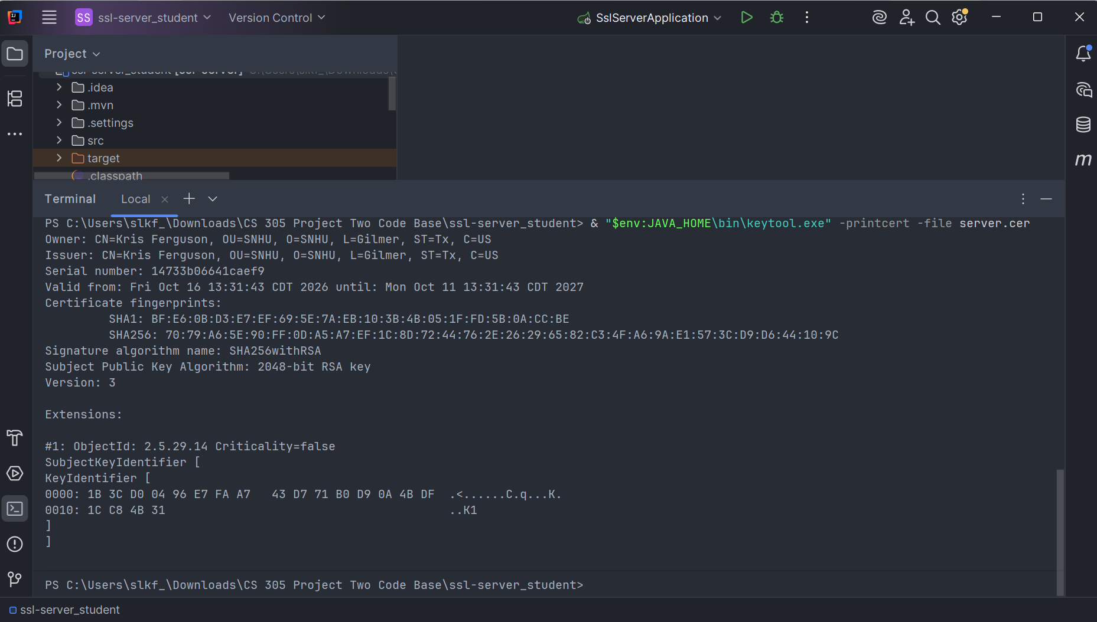

Deploy Cipher
Insert a screenshot below of the checksum verification.

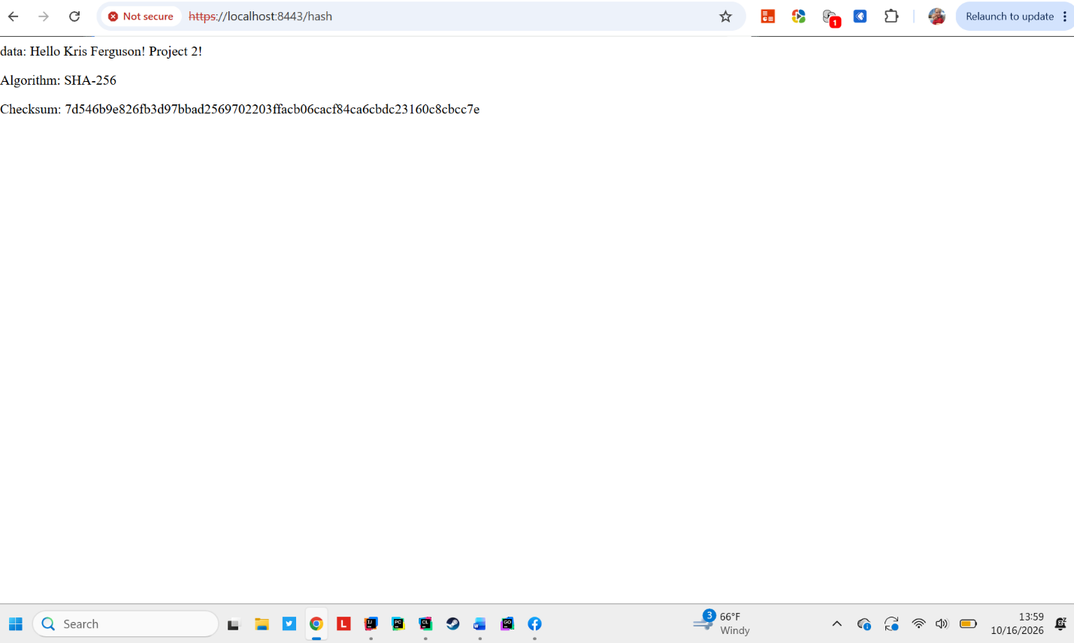

Secure Communications
Insert a screenshot below of the web browser that shows a secure webpage.

Secondary Testing
Insert screenshots below of the refactored code executed without errors and the dependency-check report.

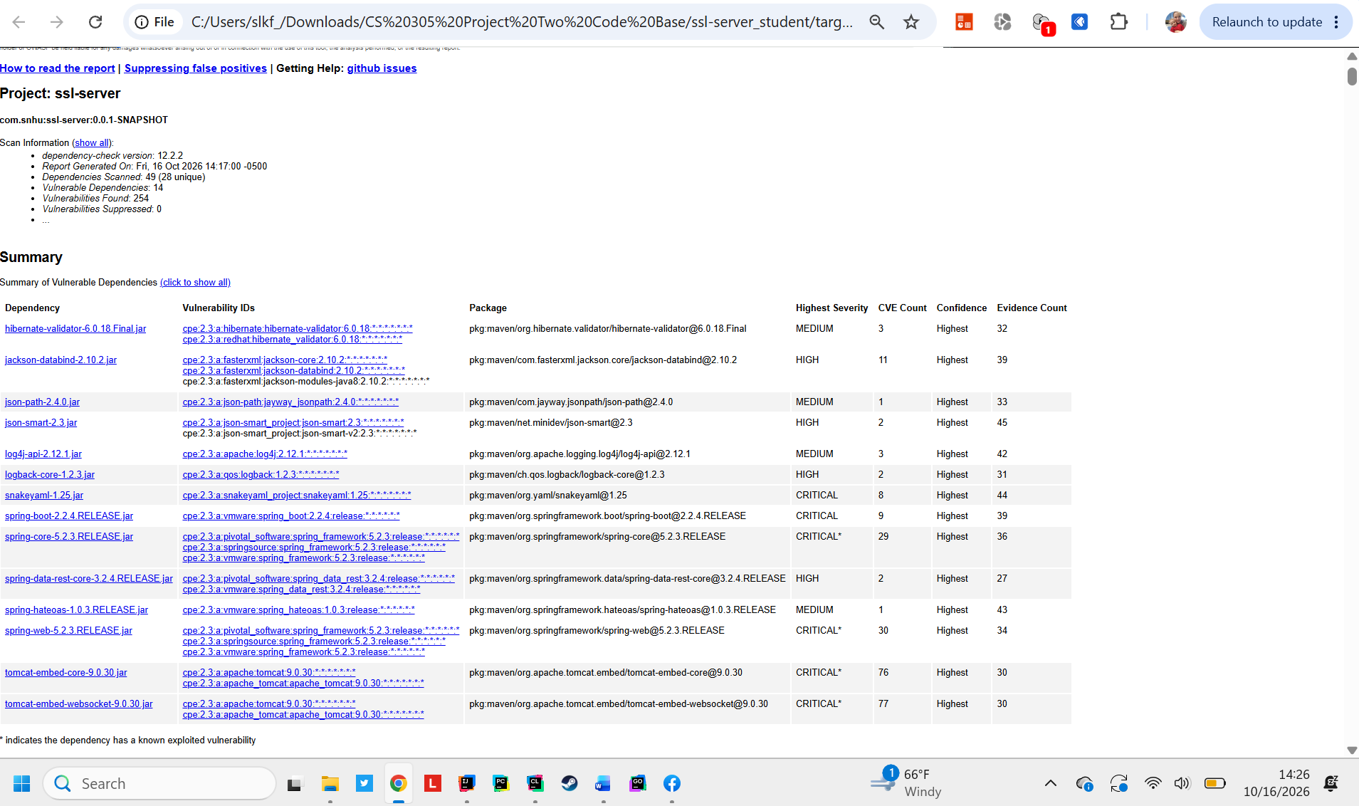

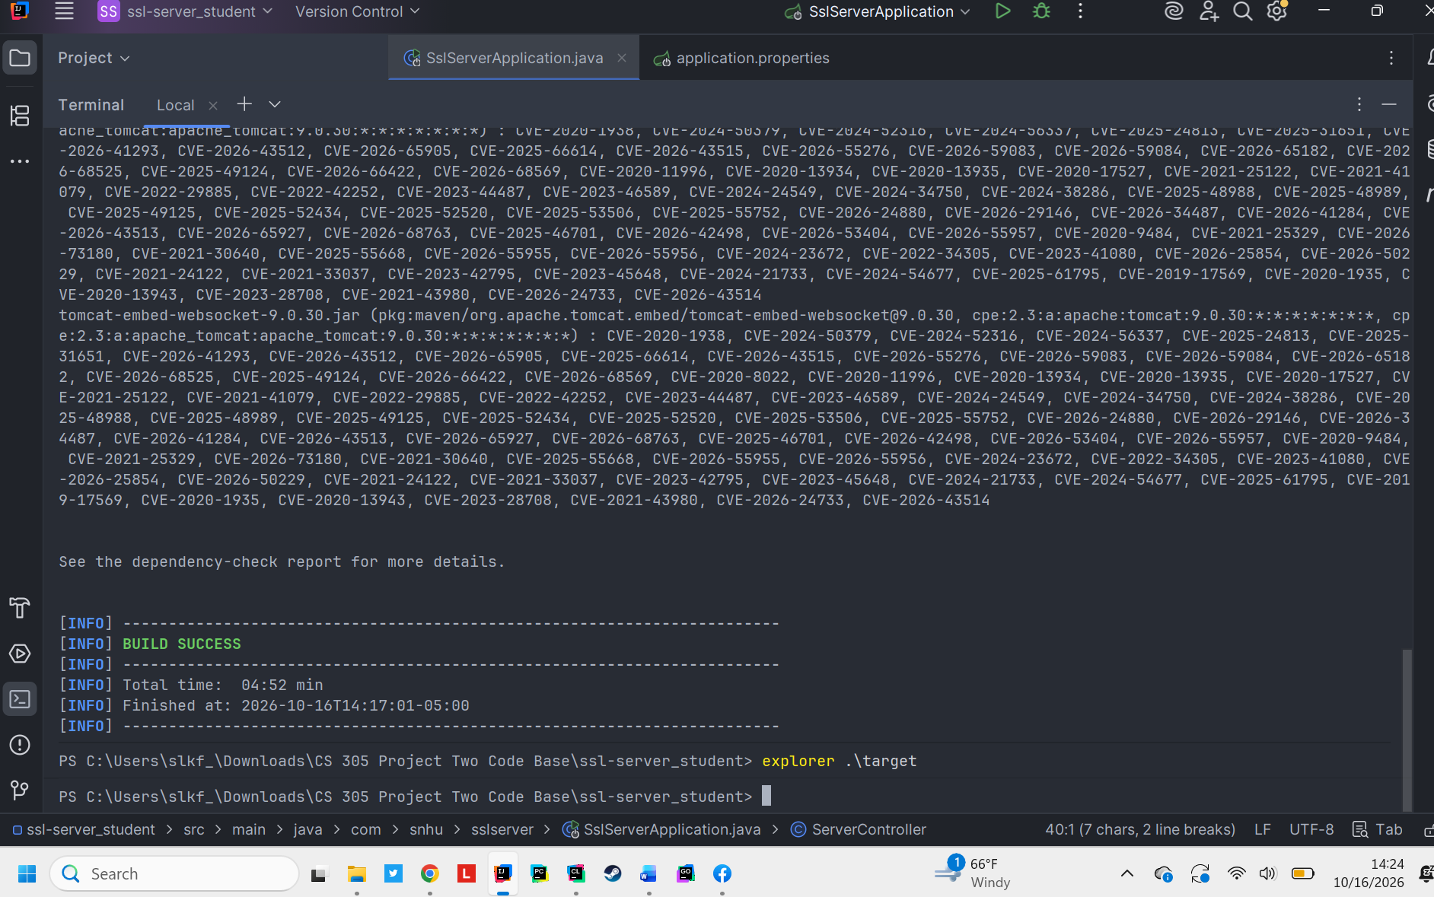

dependency-check-report.html included in codebase

Functional Testing
Insert a screenshot below of the refactored code executed without errors.

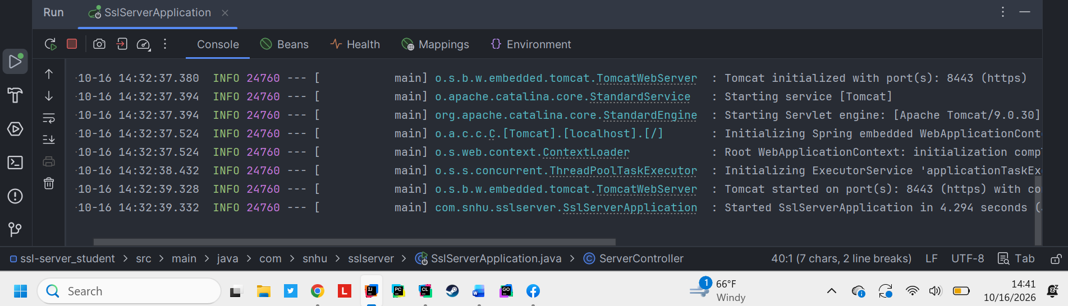

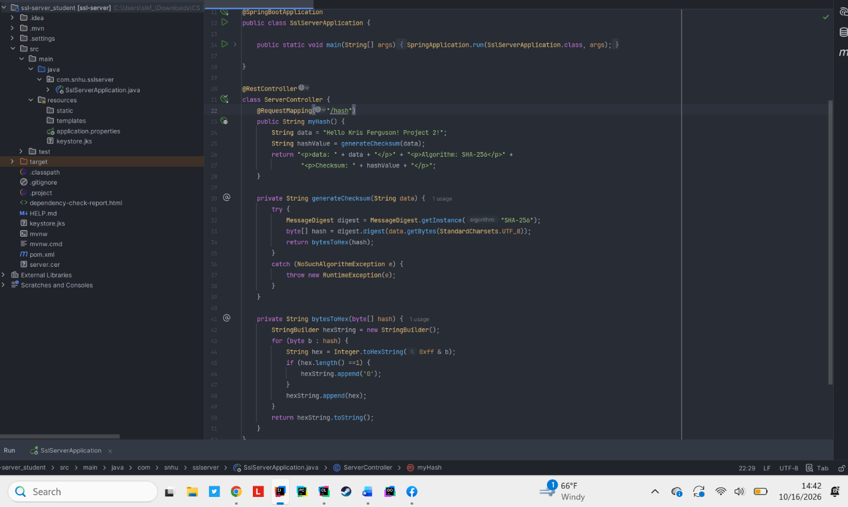

Summary

In the process of refactoring the processes that were added that map to the vulnerability assessment diagram are secure communications, code quality, encapsulation, and encryption. application.properties sets the port at 8443 and points Spring Boot at the keystore produced by keytool. The embedded Tomcat starts an SSL connector, traffic to /hash is encrypted and the self-signed certificate authenticates the server. The /hash endpoint hashes a unique string that includes my name with SHA-256 and returns a 64 character digest. The dependency check after the refactor shows only the pre-existing vulnerabilities, no new vulnerabilities were added. The layers of security are: generate a key pair and certificate, bind the keystore in configuration, force HTTPS, and expose a checksum the client can recompute. Each step is independent from another which mean sone step can be removed without affecting the others. For Artemis Financial this means that client documents and identifiers securely move back and forth. HTTPS stops passive eavesdropping and the checksum gives a way to detect tampering. Using the standard algorithms and tools means the controls can be reviewed and audited without depending on a single developers custom implementations.

Industry Standard Best Practices

The changes follow the current gold-standard practices for cybersecurity, AES-256-GCM and SHA-256. The certificate was generated with keytool, which is the standard Java tool. TLS is enabled by framework configuration. Dependency-Check was run after the change which is a normal part of the DevSecOps pipeline, which confirmed no new vulnerabilities. Existing security was untouched as were the existing vulnerabilities, which have been/would have been correctly documented and appropriate ones suppressed.

